**PROBLEM SHEET 1_19PW22**

1. Create a table employee with fields Name (varchar (15)), Designation (varchar (15)), Dept. (varchar (15)), Salary (int), Phone_number (bigint(10)).

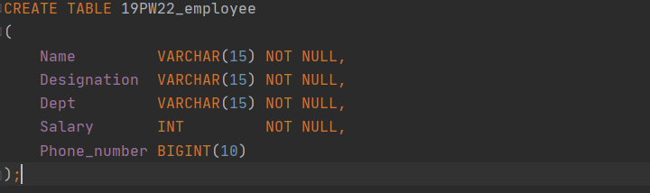

2. Add a new column ID (int) as the first column in the employee table.

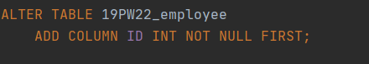

3. Add another column City (varchar (15)) after the Salary column and Last_name (varchar (5)) after the Name column.

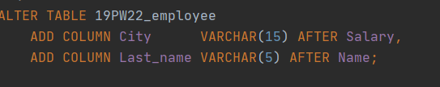

4. Change the size of the column Last_name from 5 to 20.

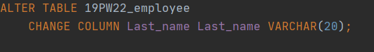

5. Add a new column Date_of_joining (date) at the end of the employee table.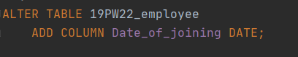

6. Change the name of the column ID to EID.

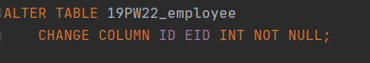

7.Add not null constraint to City.

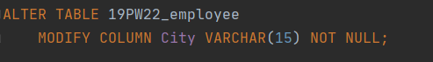

8. Remove the Last_name column from the employee table.



9. Create a table dup_employee using employee (use create table as)

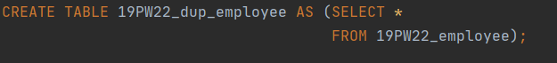

10. Change the name of the table employee to employee_data.



11. Delete the dup_employee table.



12 Display the schema of the employee_data table. (use desc (or) show columns from).



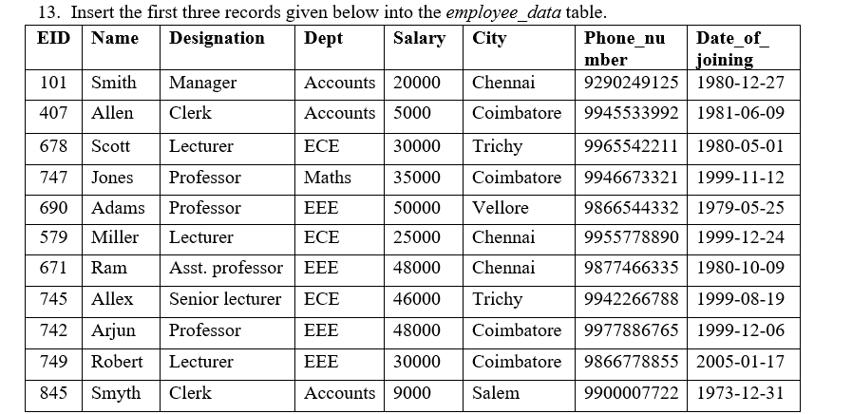

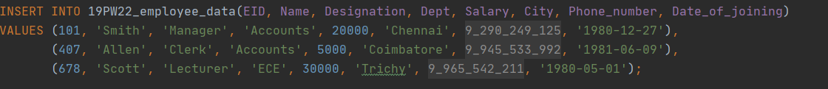

14. Remove the three records inserted into the employee_data table using a single SQL statement.



15 Write a SQL statement to make sure that no duplicate data against column EID will be allowed at the time of insertion.

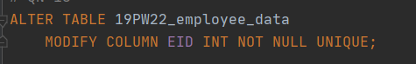

16. Insert all the given data into the employee_data table using a single SQL statement.

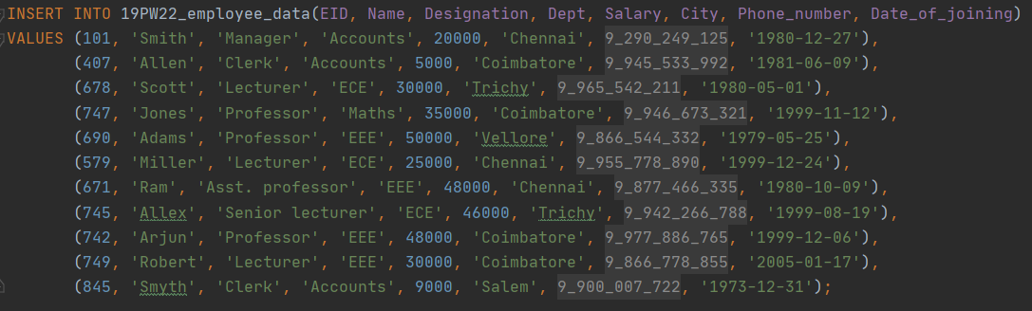

17.Create a table CBE_employees (using employee_data table) that includes the details of employees who are from Coimbatore city. (use create table as)

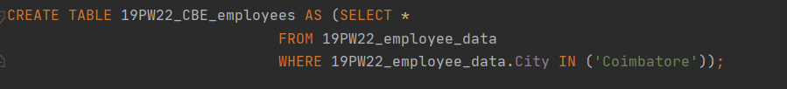

18.Create a table Subset_employee and store only the values of EID, Name, Designation, and Phone_number columns of employee_data table using a single SQL statement. (use create table as)



19. Add a constraint to the Department column so that the domain values for this column are restricted Accounts, ECE, EEE, and Maths. (use check constraint)



20. Add a constraint to the Salary column so that it takes any value in the range 5000-50000. (use check constraint)



21. Add a constraint to Phone_number column to store only distinct values. (use check constraint).

